Data Provider of Asset Crawlers Database

Crawl Ticket from ETLE System and API to Inquiry the Result

# Project Overview:

1. Engineer required to build crawler engine to automated checking process of ticket- (*tilang*) from ETLE (Electronic Traffic Law Enforcement) system and store the results checking to databases where the data can be used by others application through API
2. Analytics want to create dashboard to view status e-tilang of customer asset

# Standards:

* Database used to store the data should be PostgreSQL, MySQL, other Open sources RDBMS
* Crawler Engine should be developing by Python (free to use any library or services as long as it’s open sources)
* API should be creating in Python (free to use any framework e.g. Flask, FastAPI, etc.)

# Objectives:

* Create database in PostgreSQL or MySQL to store the data of check results
* Create crawler Engine using Python to automate checking process to the sources (ETLE)
* Create API to enable checking result data can be consumed by other application
* Create table to view status e-tilang of customer asset (*result from test-1*)
* Archive all codes files in repository (free to use any repository e.g. GitHub, GitLab, etc.)

# Outline the Architecture of the solution:

# *This is where candidate put the architecture diagram*

# Outline the steps/plan of the solution:

# *Step 1*

# *Step 2*

# *Step 3*

# *……..*

# List down the requirement/tasks required:

# *Task 1*

# *Task 2*

# *Task 3*

# *……...*

# Record your notes/project here:

*This is where candidate can record/documented their project, free to use complete their project.*

# Summarize what you learned:

*This is where candidate car record What did you learn? What worked well? What was the most challenging aspect of this project? What will you do differently next time?*

**Appendix**

**ETLE System need to be automate check by the engine crawling**

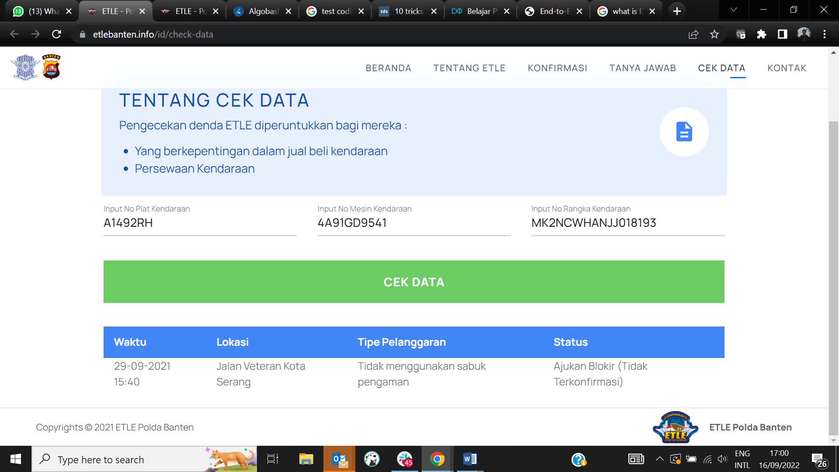

**URL**:

[**https://www.etlebanten.info/id/check-data**](https://www.etlebanten.info/id/check-data)

**Sample Data:**

* Input No Plat Kendaraan : **A1492RH**
* Input No Mesin Kendaraan : **4A91GD9541**
* Input No Rangka Kendaraan : **MK2NCWHANJJ018193**

Sample API

